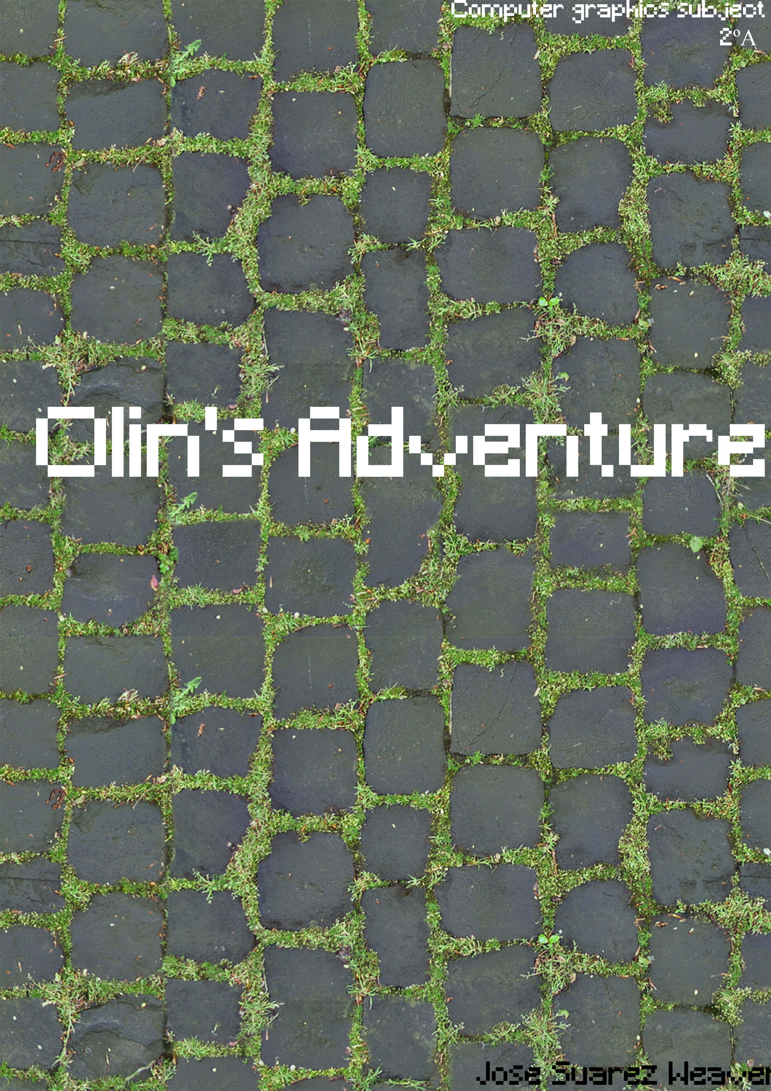

## INDEX

1. **Game Specification.**
2. **User Story.**
3. **Planning Game.**
   1. **The starting and ending date.**
   2. **Screenshots.**
4. **Class Diagram.**
5. **Problems and solutions.**
6. **Conclusions.**

**1.Game Specifications.**

**Game Description:** The goal of the game is to kill all the enemies before they spread out. Enemies will be spawning constantly each 0.8 seconds. So you’ve to kill them all with Olin’s hate.

**Game Elements:** There are four types of elements, first of all, the Main Character that’s a loaded object, the enemy another loaded object, the projectile, that’s a pyramid that is created with the fire function that belongs to the main character, the last element belongs to the environment.

Video: <https://www.youtube.com/watch?v=o4Pje3kQgLQ&feature=youtu.be>

**2.Planning The game:**

The main objective that I put to myself is the same objective of the subject. Understand how the graphic pipeline Works, and I think I more less got it.

**First Release:** I created the main geometry of the game (cubes & pyramid), also created some inputs for character movement, and played a Little bit more with the graphic pipeline. 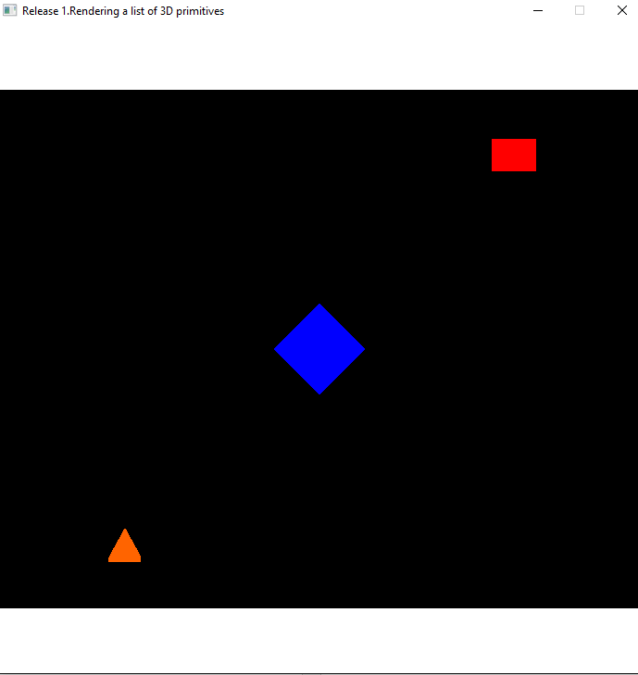

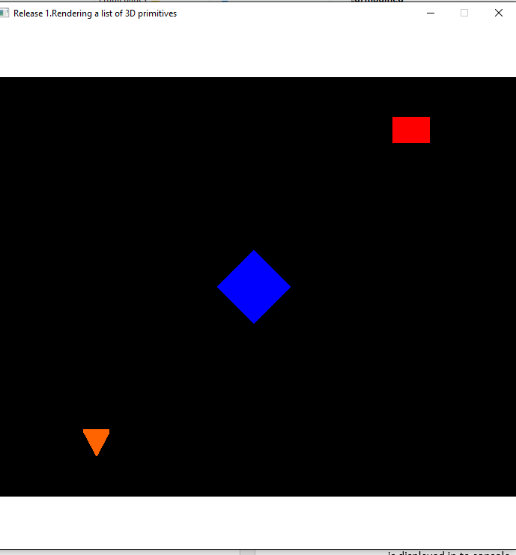

**Second Release:** I worked out how to create a camera and how some uniform matrices work (View, viewport, model…), also learned to use better the vertex and fragment shader.

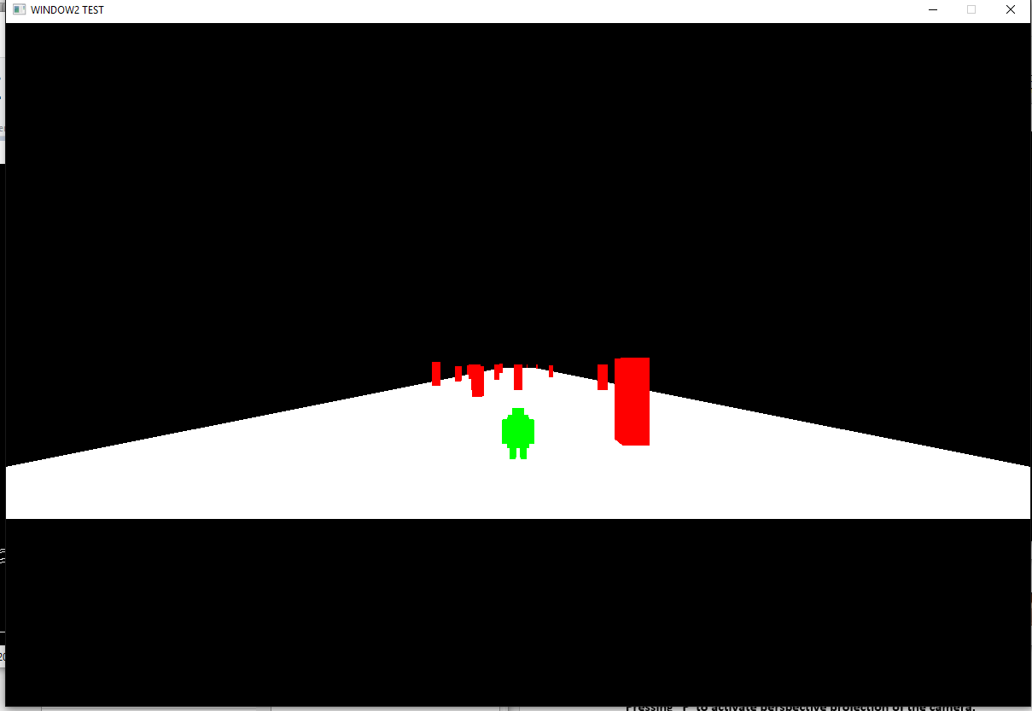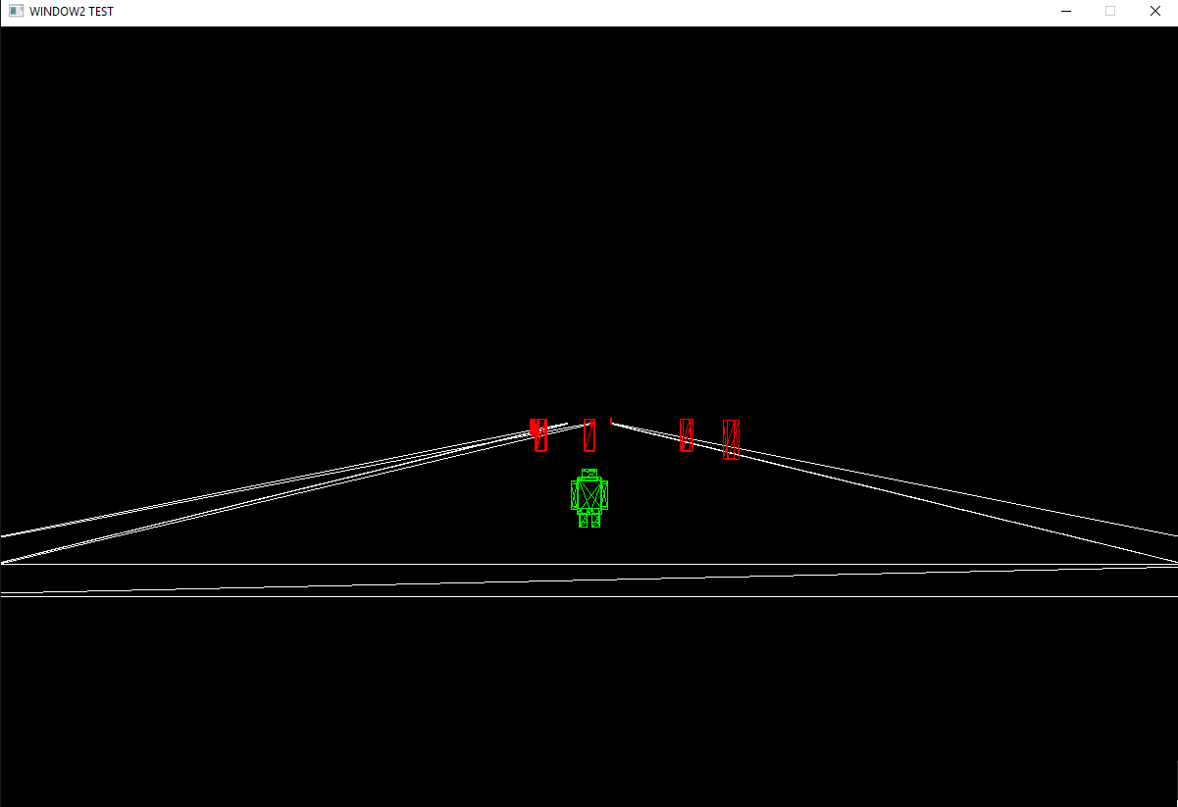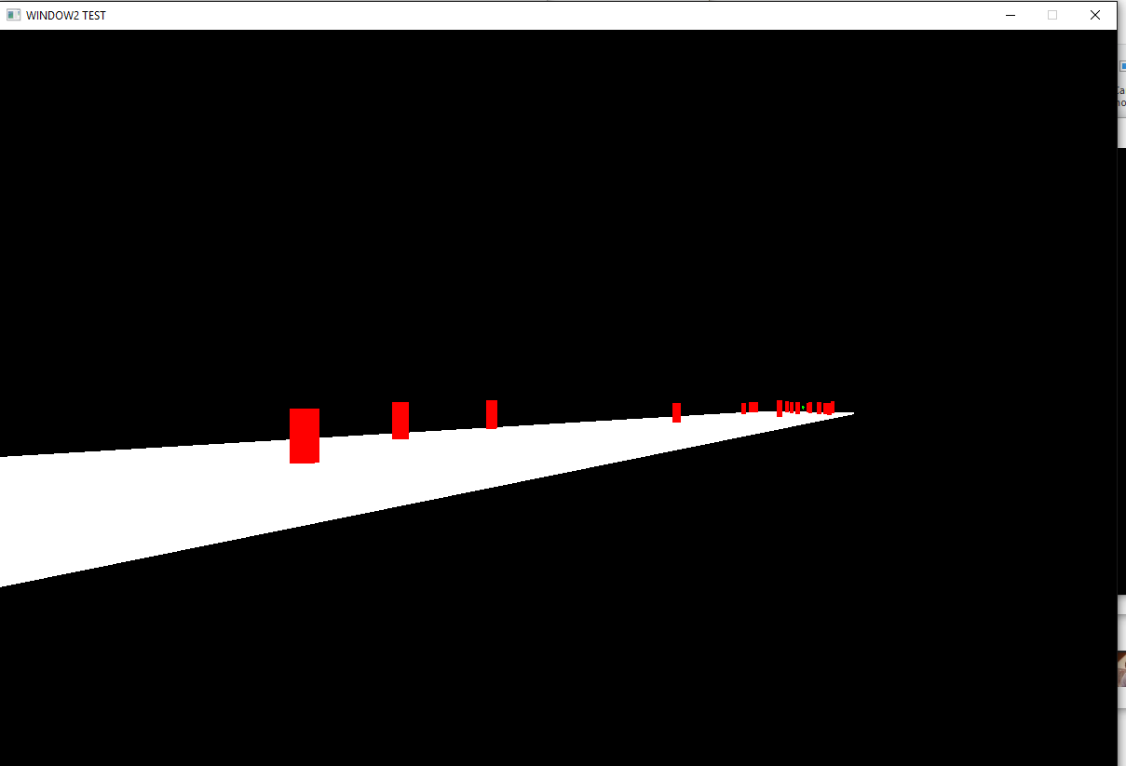

**Third Release:** Learned finally how shaders work. Textures are included with different modes of blendings. Phong reflectance model is included, and different lights also Works.

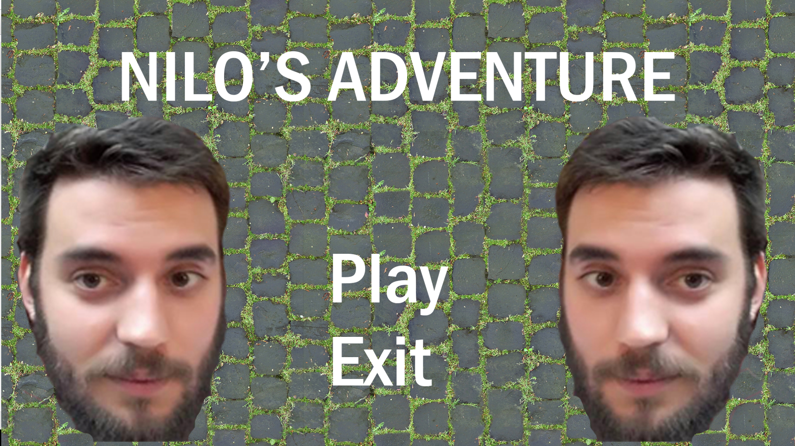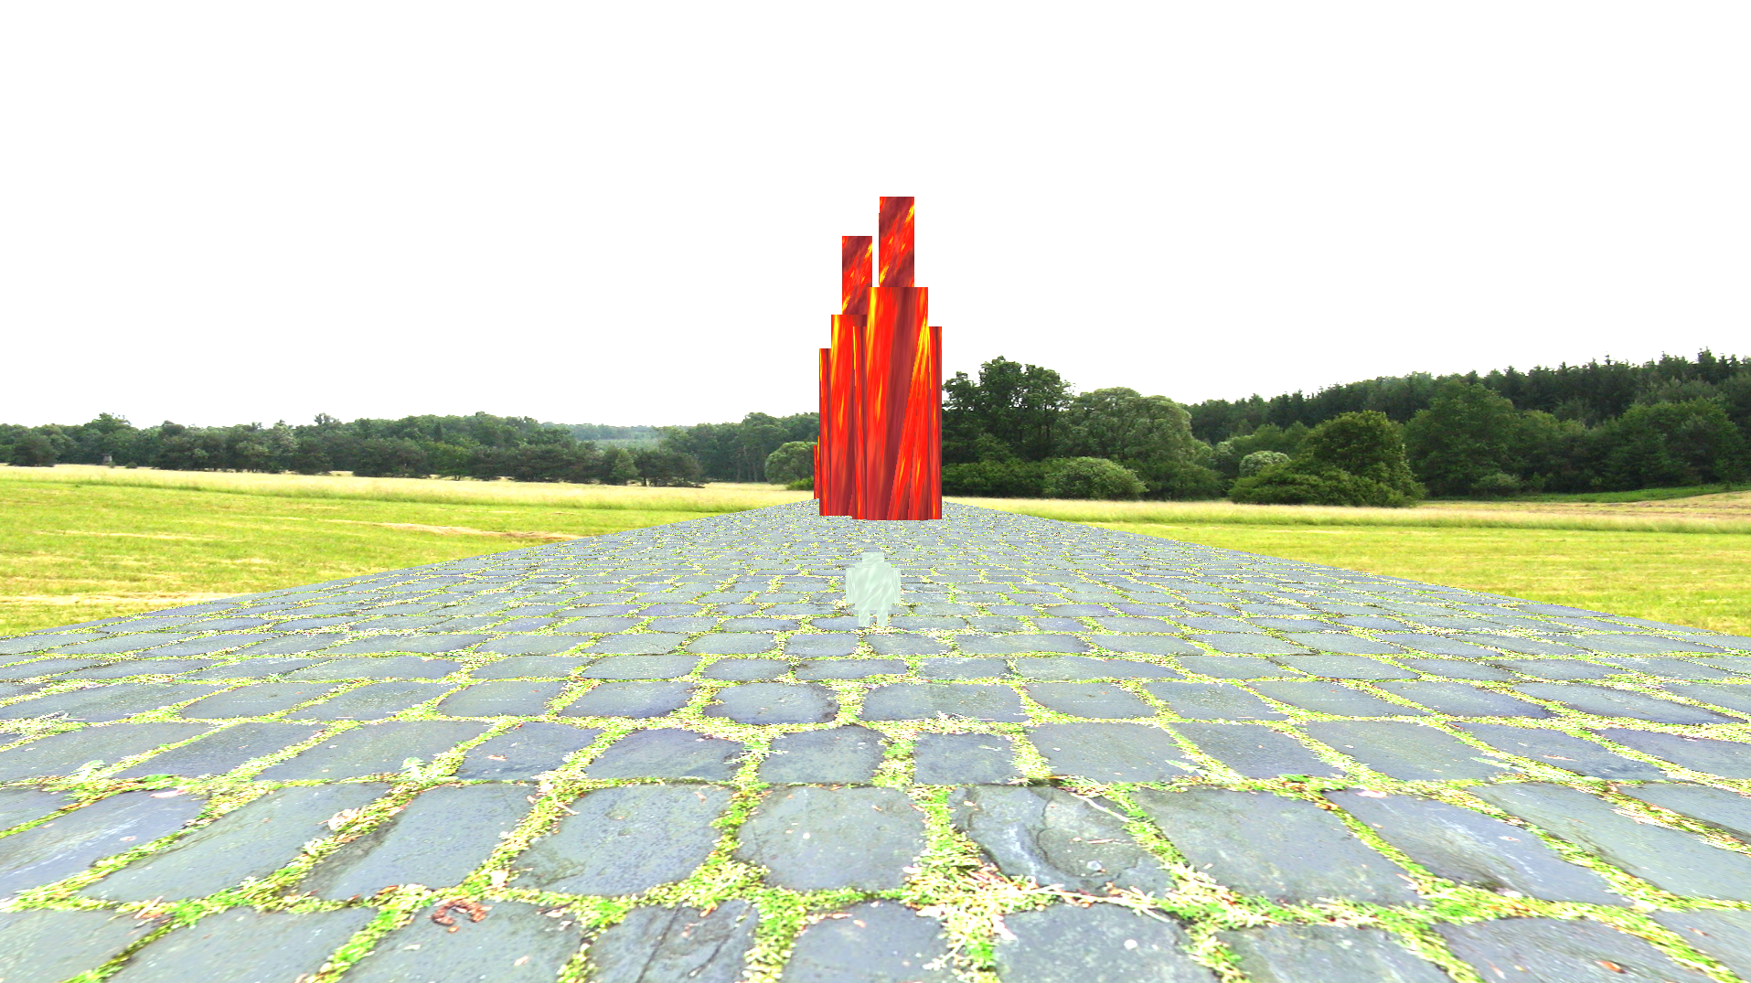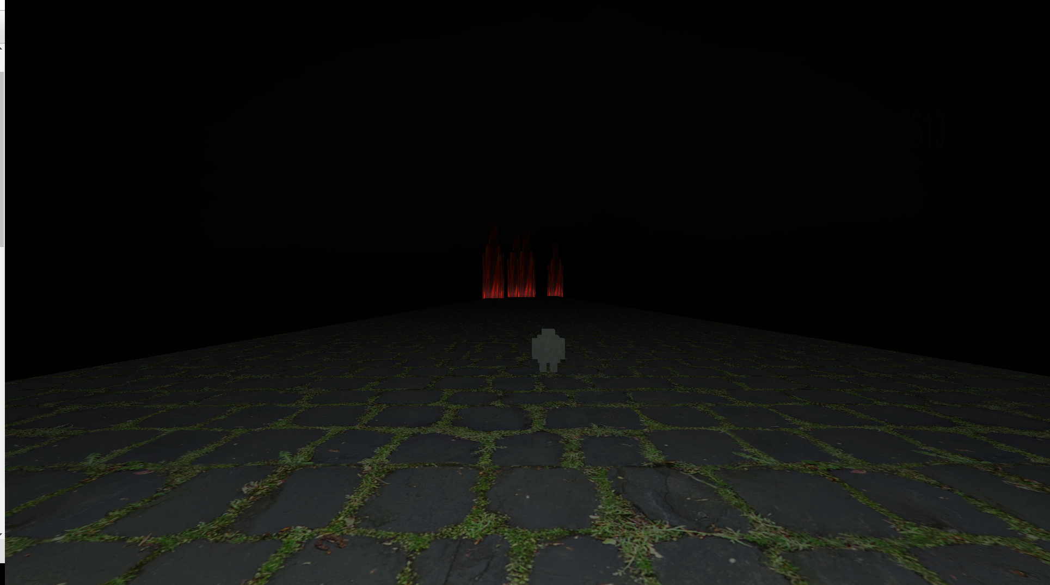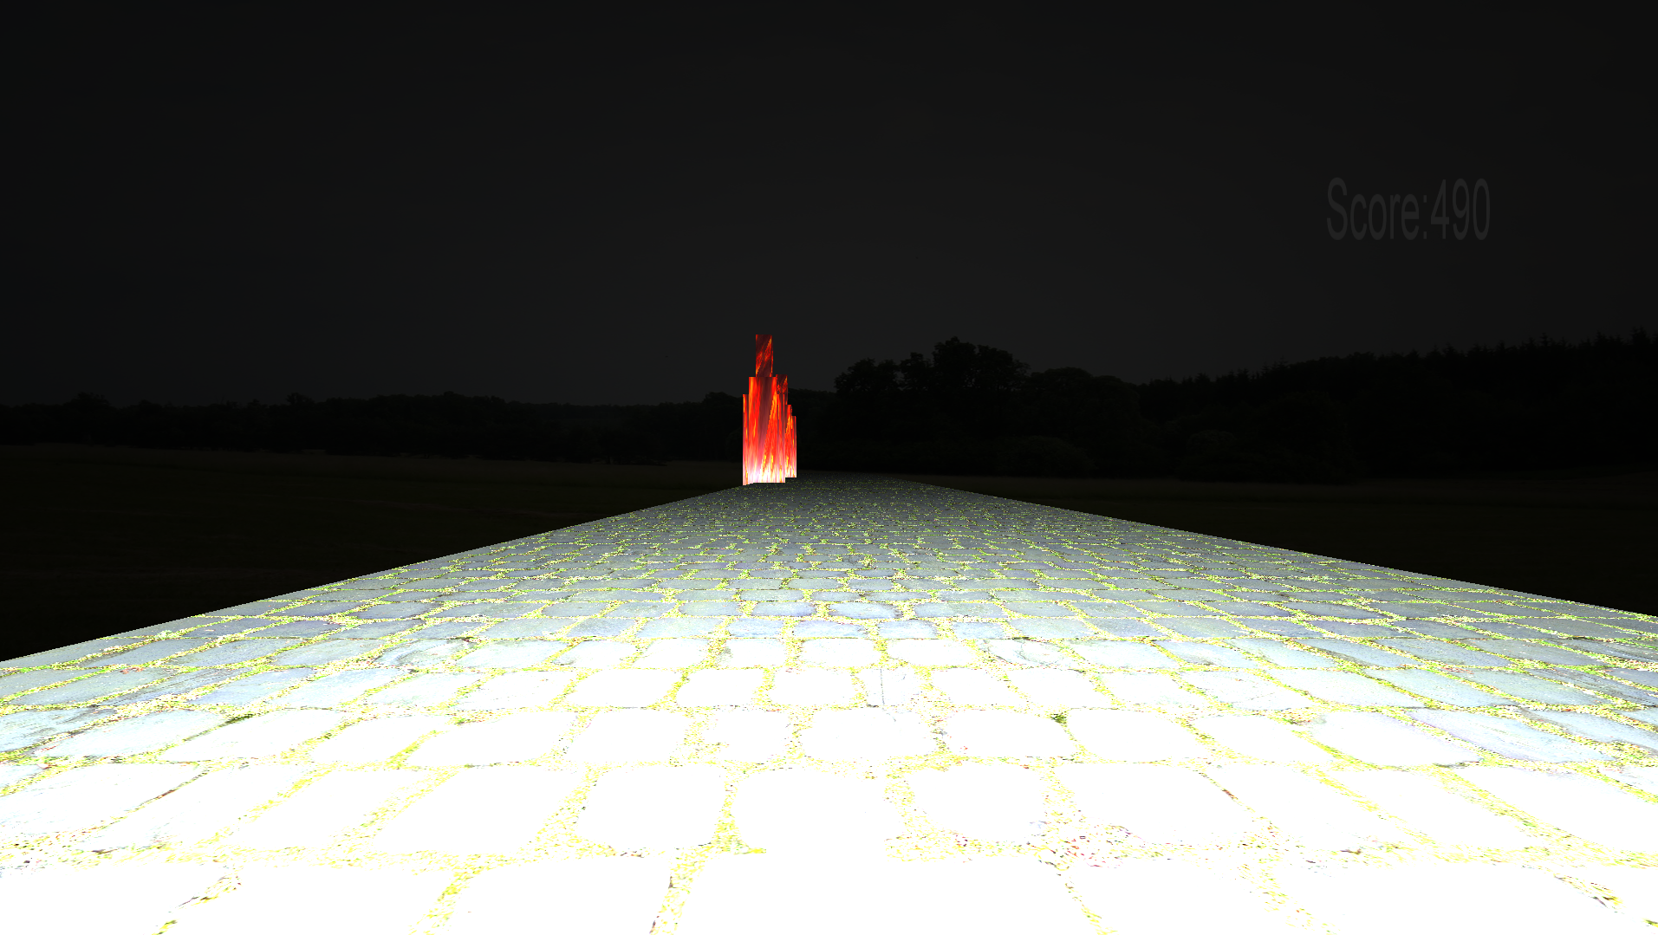

# **Release 3 – Reality Comes True – User Story (Jose Suárez Weaver).**

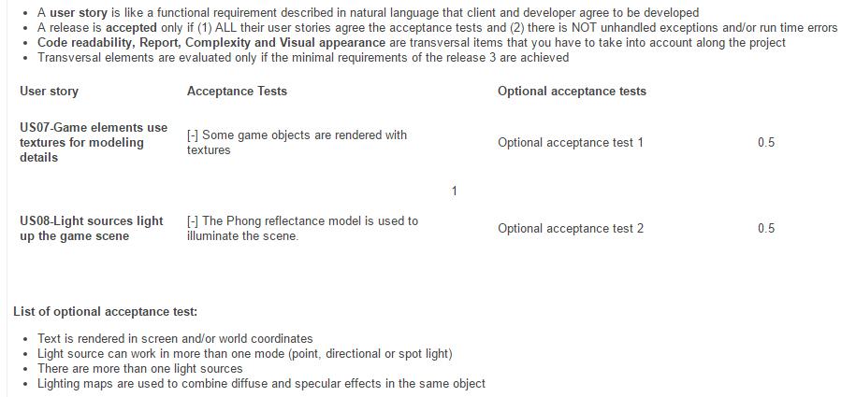

# **How I achieved it.**

US07 – Some objects are rendered with textures:

1. Object textures are loaded with a texture file reference, depending on the object type, each object will have a different file reference.
2. Text is rendered in screen and /or world coordinates. The score and the win/lose screens also are rendered in screen coordinates thanks to the textManager class.

US08 – Light sources light up the game scene.

1. The Phong reflectance model is used to illuminate the scene, thanks to the MaterialManager class, and to all the uniform variables that we send to OpenGL this acceptance is achieved.
2. There are more tan one light sources, also you can switch between ambiental lighting, direct lighting and point lighting by pressing “P”. Each enemy has also point lights to see the result.

# **Inputs**

**Right and left arrows -> Move the character.**

**WASD, Up and down arrows -> Move the camera (No gameplay intention).**

**Right Click -> Change Camera.**

**Left Click -> Attack.**

**Pressing “L” to activate GL_LINE**

**Pressing “F” to activate GL_FILL**

**Pressing “B” to actívate both of them.**

**Pressing “P” to activate perspective projection of the camera.**

**Pressing ”O” to actívate orthographic projection of the camera.**

**Press “R” to restart the game once you’ve lost or won || you will change the drawMode.**

**Pressing “P” you’ll switch between different lights.**

**Pressing “L” you’ll actívate or deactivate lighting.**

**Lighting intensity can be changed with “+” and “-“ keys, depending if you want more brightness or less.**

**4.Class Diagram.**

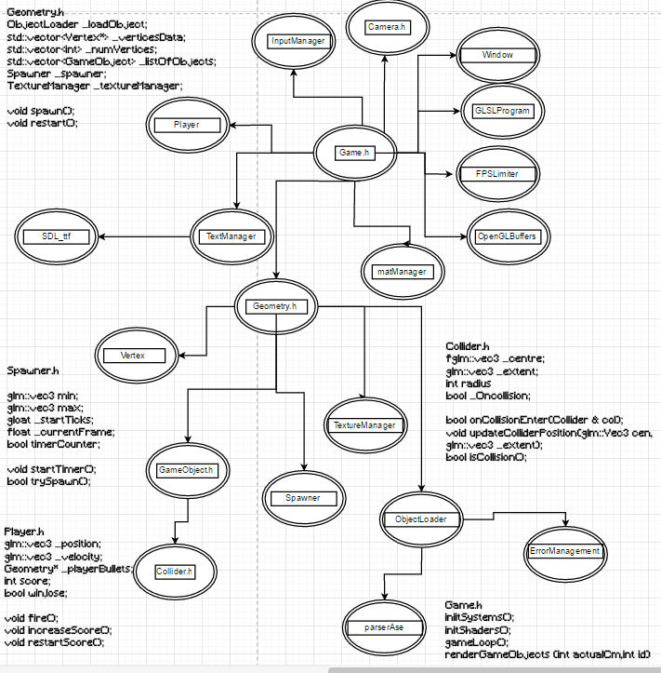

**5.Problems and solutions.**

**1.- Understand propertly the graphic pipeline:** That’s a tough challenge to me, didn’t know what’s going on with most of the openGL functions. But with Albert’s help It was kind of easy to understand some strange things.

**2.-Understand the Geometry class and the way that we created geometry.**  It was strange at first when I started creating a cube, after a lil’ time I realised that we were creating prefabs that after would be transformated by the model transformation matrix. How to remove and add gameobjects was another tough challenge at first.

**3.-** **Uniform variables and Shaders.** Sending information to shaders was a Little strange when we used it for the first time, but with a lot of time on it I’ve started to understand how they work and why in that way.

4.-**Lights**. I didn’t know if they were right or wrong, had to put some time to get it working. But it was worth the work!

**5.-Collision Problems.**

**6.Conclusions.**

I’ve got to say a few things right here, I feel I’ve progressed a lot since first time I used openGL, although, when I started the first release, we came from programming technology, so I tried at first to do everything clean and useful, the main problem was that I didn’t understand a lot of things in openGL, so I left it simple and started programming not as clean as I like to do it. I feel very satisfied with the final result, and wanting to start another openGL Project soon.

The most difficult task is to understand the pipeline and how it really Works. I mean passing variables through the pipeline is a pain in the ass, but when you start to understand it, it becames really really mechanic.

The easiest task would be to print something for the first time, It wasn’t much a challenge if we Paint without cameras.

The weakness is that not many things I did in this Project are reusable because I didn’t program capsulating code. The strength may be that in the end I started to clean the code, and some functions are really useful to work with openGL. Also most of the variables that I send to the pipeline, can be changed ingame with inputs, and that’s kind of cool.

I’d definately do things better, but I lost motivation for some uknown reason, and had some bad experiences with openGL at the beginning, although in the end I started enjoying it.

I’d first add attack from the enemies, and would change some mechanics in order to make things less static.